# Experiment-3.1

## Student Name: Nabha Varshney UID: 20BCS4995

**Branch: CSE Section/Group: 20BCS-DM-704 (A)**

## Semester: 6th Date of Performance:18th Apr 2023 Subject Name: Competitive Coding II Subject Code: 20CSP- 351

**Aim** – To demonstrate the concept of greedy approach

## Objective-

* The objective is to build problem solving capability and to learn the basic concepts of data structures.
* The implementation of Find the difference which shows and brushes up the concept of Divide and

Conquer can be solved through various approaches.

* The implementation of Assign Cookies using greedy Approach

## Remove Duplicate Letters

<https://leetcode.com/problems/remove-duplicate-letters/>

**Code –**

class Solution {

public:

string removeDuplicateLetters(string s){

vector<int>last(26);

vector<bool>vis(26);

string ans = "";

int n = s.size();

for(int i = 0; i < n; i++) last[s[i]-'a'] = i;

for(int i = 0; i < n; i++){

if(vis[s[i] - 'a']) continue;

while(!ans.empty() && ans.back() > s[i] &&

last[ans.back()-'a'] > i){

vis[ans.back() - 'a'] = false;

ans.pop_back();

}

ans.push_back(s[i]);

vis[s[i] - 'a'] = true;

}

return ans;

}};

## Output -

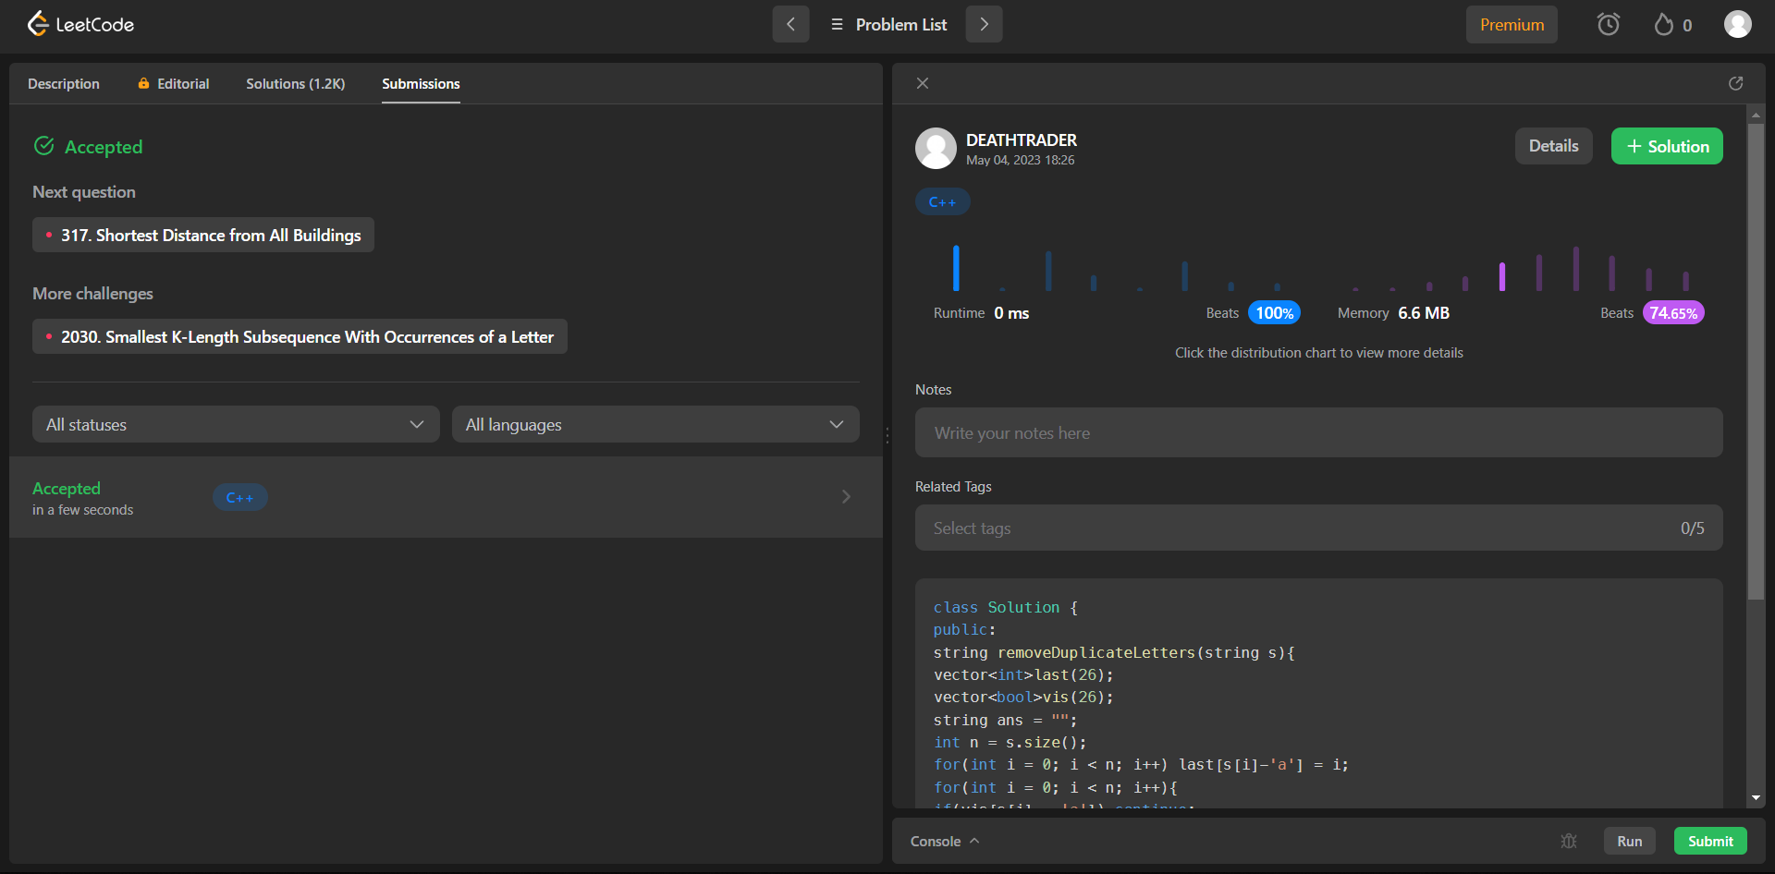

1. **Assign Cookies**

<https://leetcode.com/problems/assign-cookies/>

**Code -**

class Solution {

public int findContentChildren(int[] g, int[] s) {

int n = g.length;int m=s.length;

Arrays.sort(g);

Arrays.sort(s);

int c=0;

for(int i=0;i<n;i++){

if(s[c] >= g[i] && c<m){

c++;

}

}

return c;}}

## Output –

